**INVENTORY WEB SYSTEM**

**Prototype Design**

**Client:** Dr. [Zhengrui Qin](https://nwmissouri.instructure.com/groups/463/users/4399) (Jerry)

**Team Members:**

**Amrit Dhimal (Integration/Database Admin),**

**Sai Krishna (System Requirements / Testing),**

**Koti Reddy Nusum (Database Manager /Documentation),**

**Suresh Kumar (UI Designer/Testing)**

Login page:

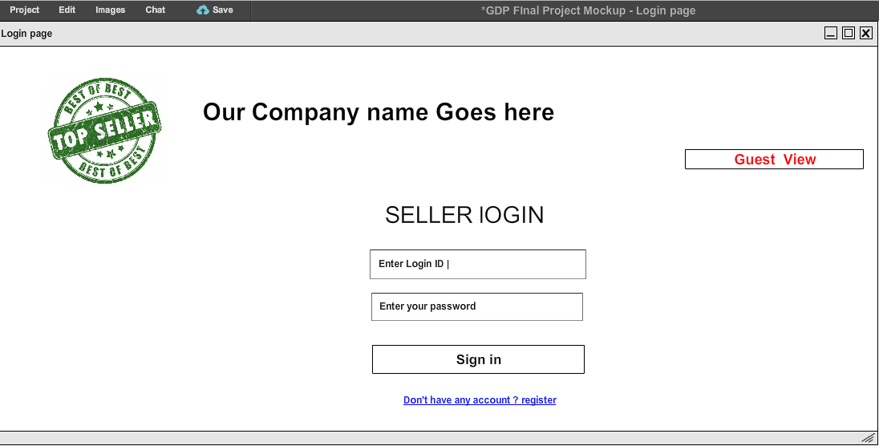

Signup page:

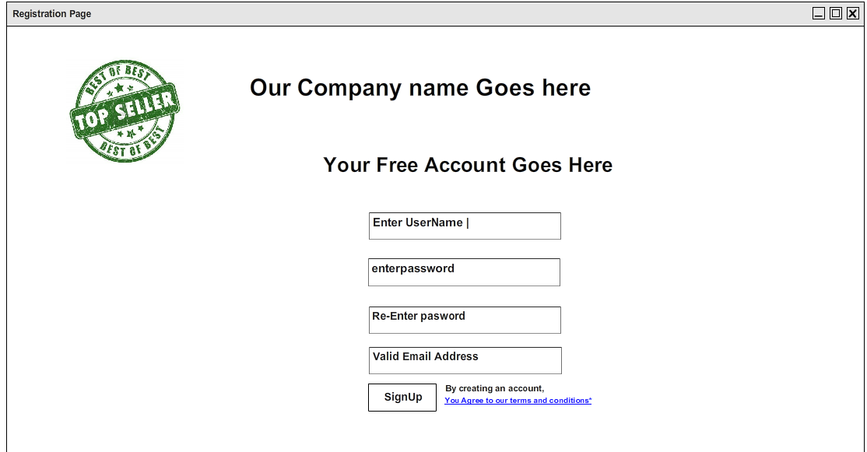

Inside seller Login:

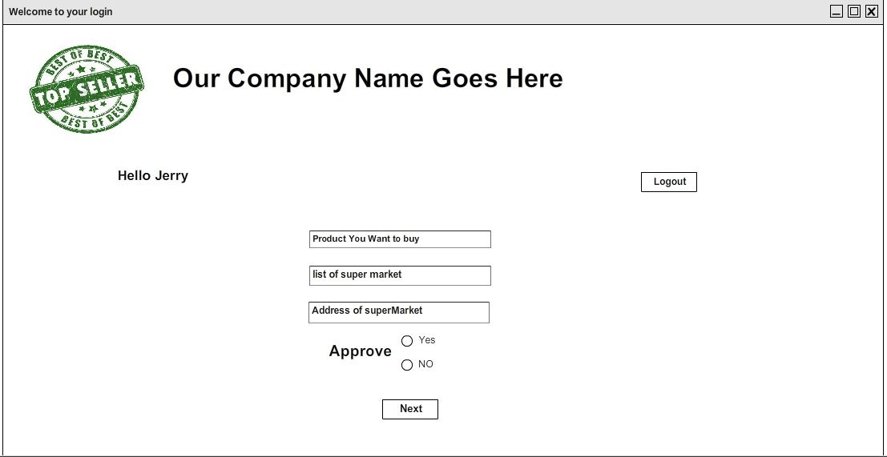

Inside seller login choosing the product to be uploaded:

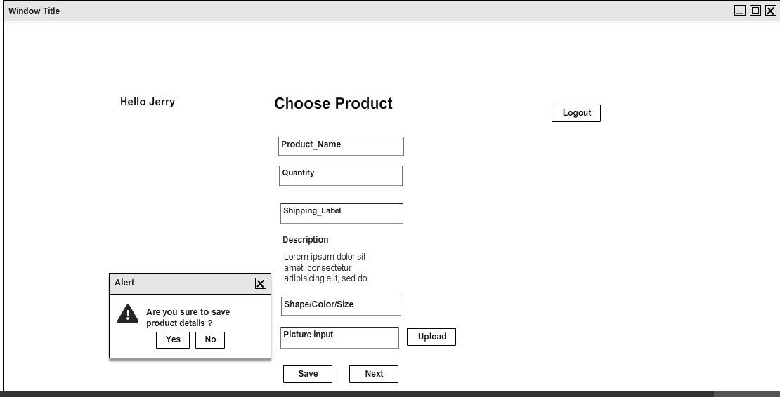

Checking Product:

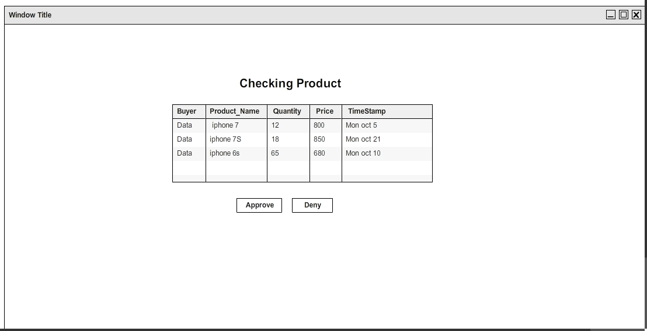

Choosing delivery location:

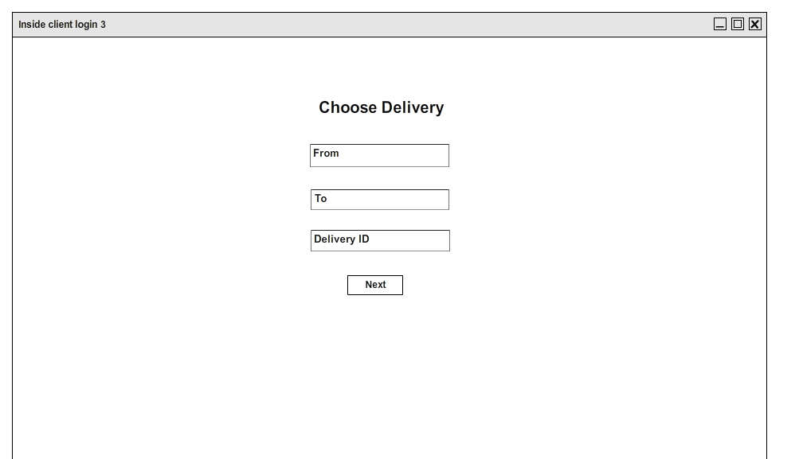

Payment:

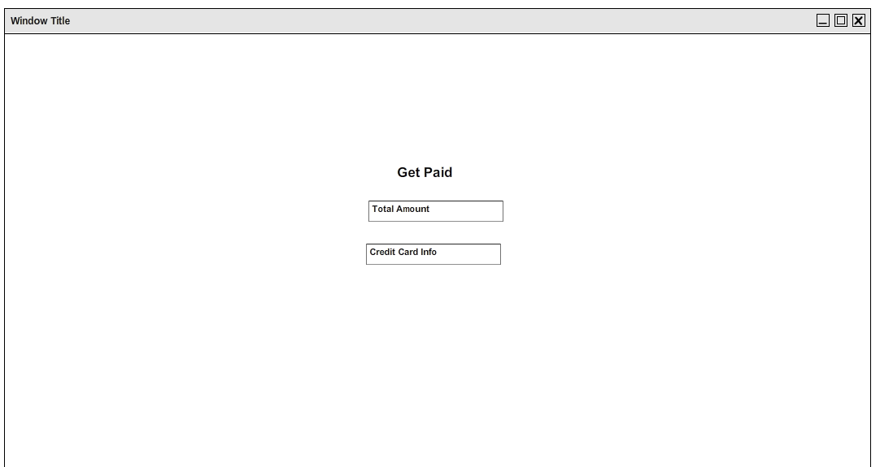

Payment process:

